**Email feedback from client**

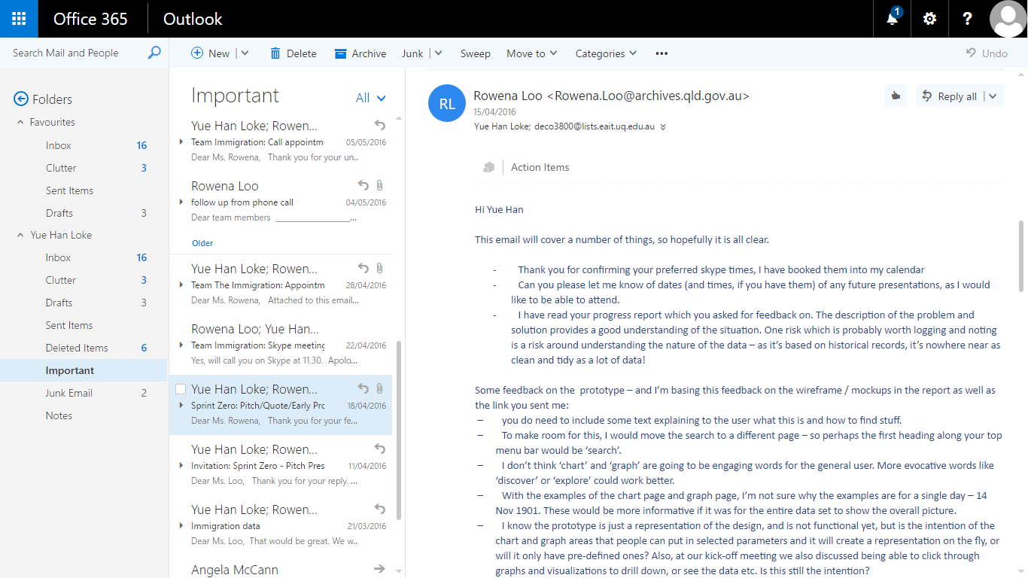

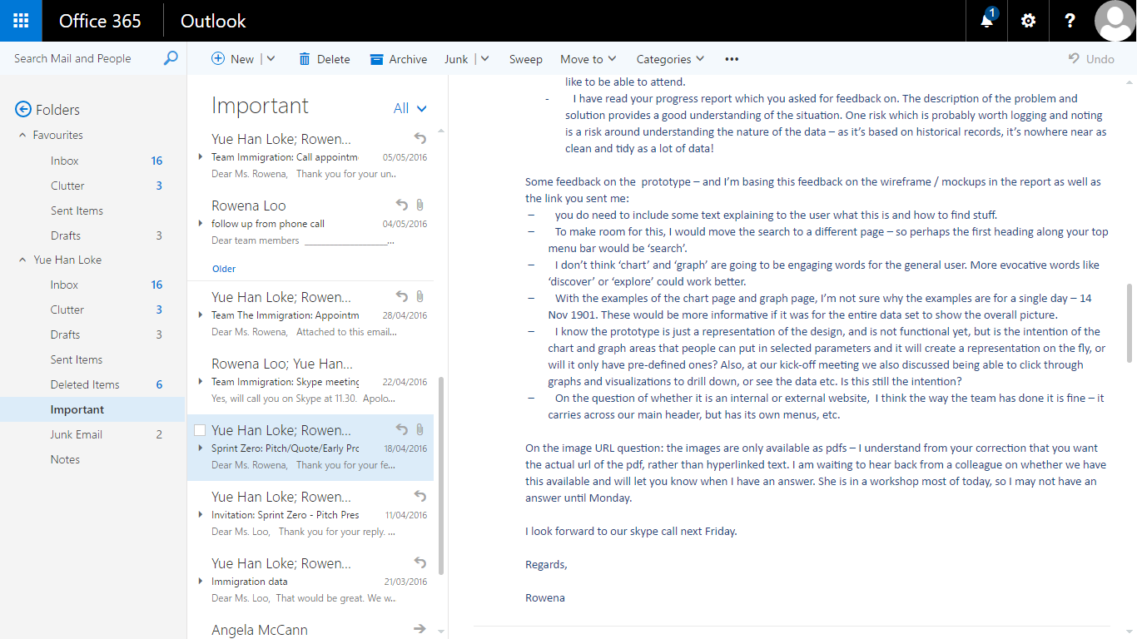

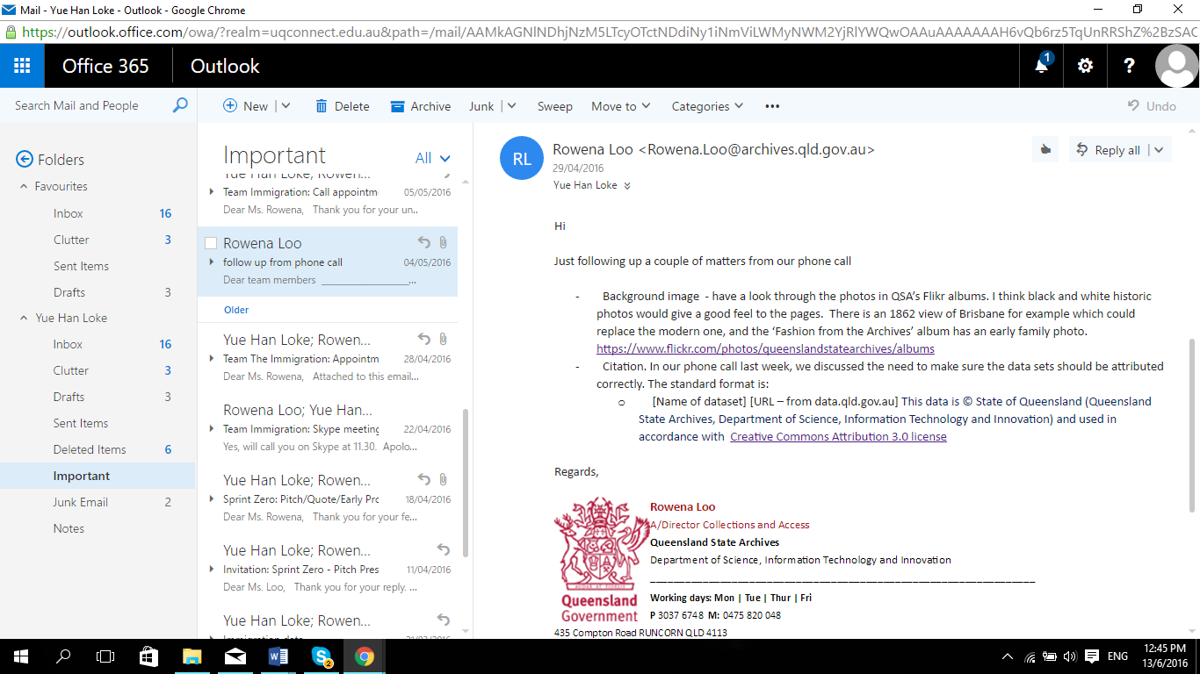

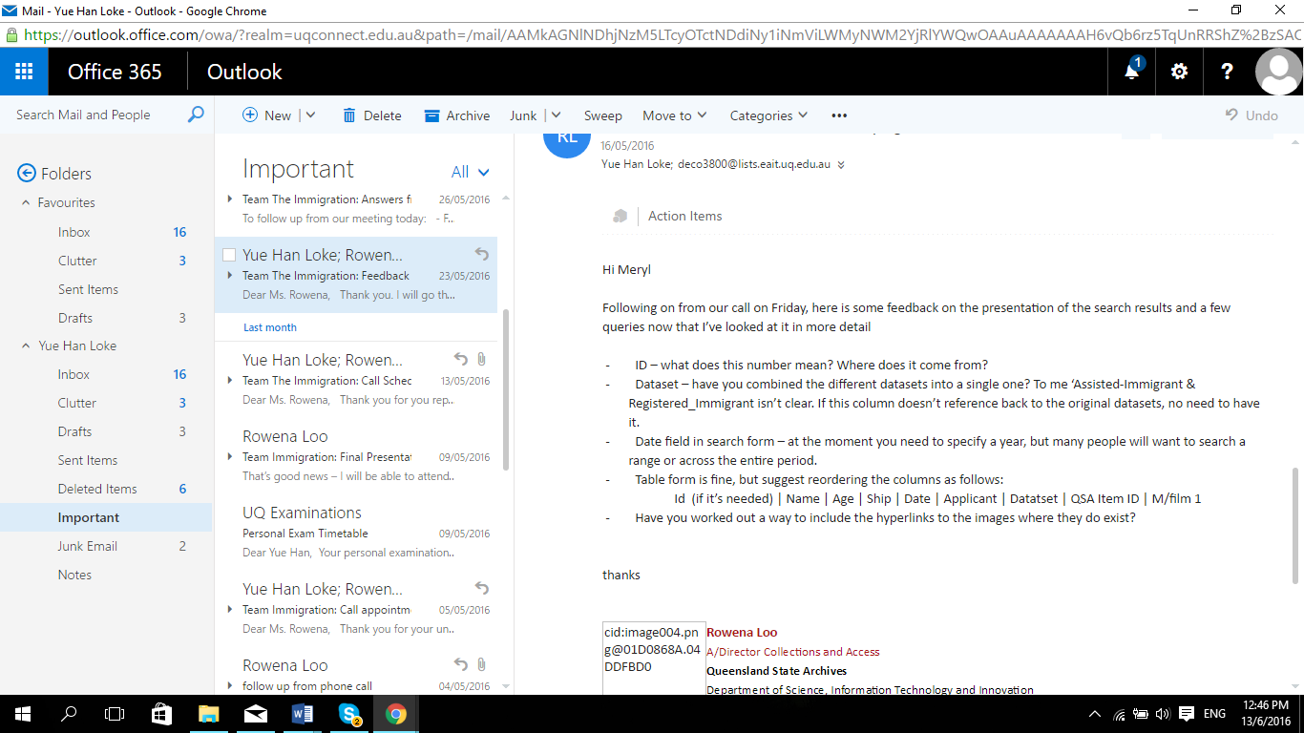

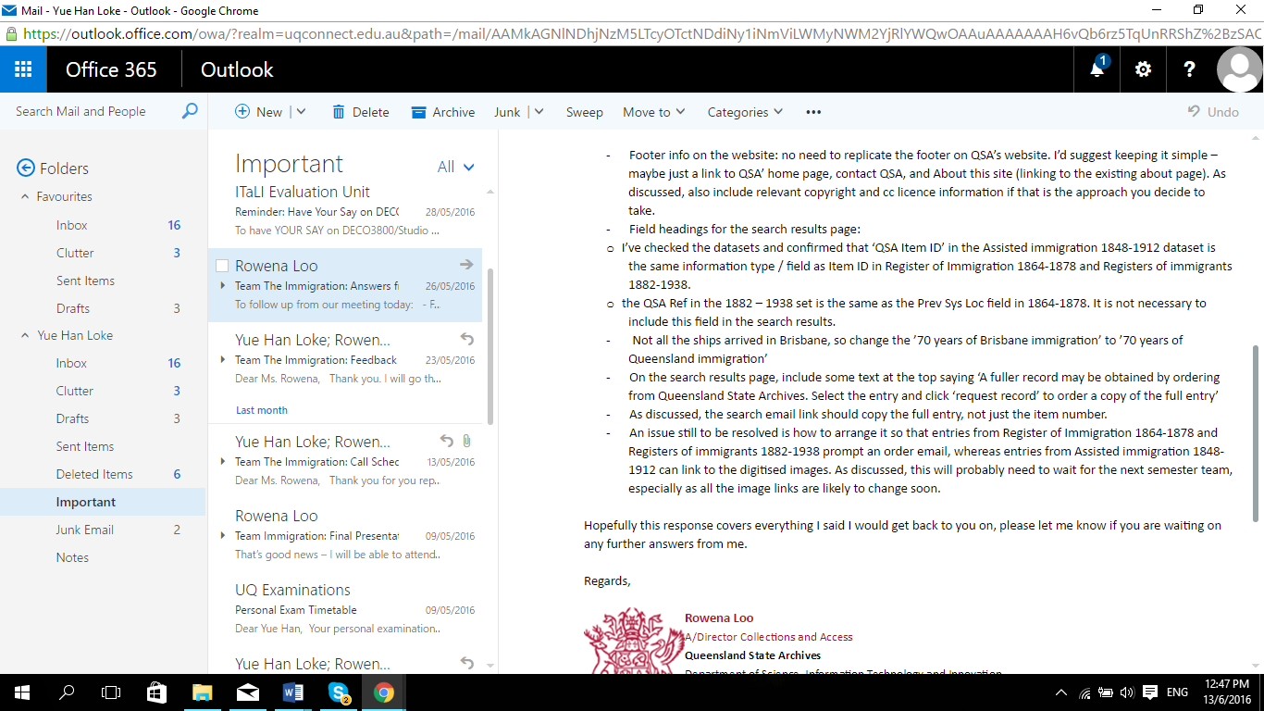

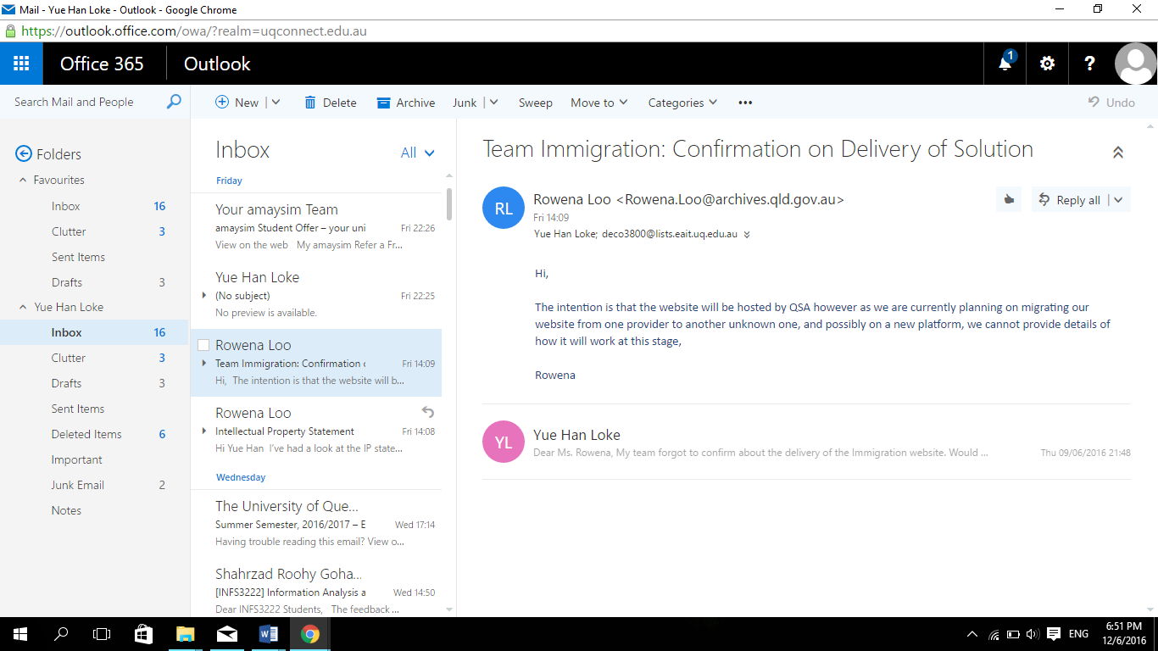

**Requirements gathered**

**18 April 2016**

1. Include some text explaining to the user what this is and how to find stuff.
2. Move the search to a different page – so perhaps the first heading along your top menu bar would be ‘search’.
3. ‘chart’ and ‘graph’ are NOT going to be engaging words for the general user. More evocative words like ‘discover’ or ‘explore’ could work better.
4. With the examples of the chart page and graph page, examples are for a single day – 14 Nov 1901. These would be more informative if it was for the entire data set to show the overall picture.
5. the intention of the chart and graph areas that people can put in selected parameters and it will create a representation on the fly, or will it only have pre-defined ones?
6. At kick-off meeting we also discussed being able to click through graphs and visualizations to drill down, or see the data etc. Is this still the intention?
7. On the question of whether it is an internal or external website, the way the team has done it is fine – it carries across our main header, but has its own menus, etc.

**22/4/2016**

1. For search, the datasets are combined
   1. Search tool include a filter for type of dataset
2. Image do not have URL links. Convert on our own. (This can be done late if possible)
3. Limitation: Images, Timeline, Charts, Graphs can be downloaded but subject to QSA’s copyright
   1. Will include the document in the terms and conditions
4. Feature of allowing users to notify an error in data by submitting a form to QSA for their review

**13/5/16**

* + - Prefers yue han’s design sent to her
    - rather than visualisation -> visualising
    - connecting the present to the past: no connection to it change -> connecting people to the past
    - linking ->
    - generate graph: click drag and drop
    - just design, will to the real design in mock-up
    - like the presentation!
    - work on it and change it: design graph
    - ship: allow timeline year to year - ship came in and how many people in the ship
    - ship: word phrase, senior citizen is modern word -> the concept that really translate so just take it out
    - Adult start from 21 y/o children below 21
    - information when click on the year in the timeline: not sure what trying to tell me
    - with that statement: not sure how we figure out the data from the datasets given.
    - ship may do more voyages in a year. main voyages or ship
    - explore page: graph. pie chart or donut chart for percentage
    - users: able to choose top 10 in explore page
    - search: rearrange the column a little bit: put the ID name date page, better order will be replied in the email
    - have something on the search tell you how to get more information
    - when someone wants to get the copy of the record of a specific person, they can email QSA for it:

Infographic:

Man icon, with the top 10 names with percentage.

Ship icon with top 10 ship names with percentage.

(Number of ships on water depends on the number voyages)

Names are clickable and direct to the search result of the names (for more information)

- result search, remove id and change to allow user to select rows to order.

- item id = QSA item, what REF in 1885-1917 prev sys loc in 1864 - 1878